**Foraging, fear and behavioural plasticity, a lesson from hummingbirds**

Katarzyna Wojczulanis-Jakubas1 & Marcelo Araya-Salas2,3

1Department of Vertebrate Ecology and Zoology, University of Gdansk, Gdansk, Poland; biokwj@univ.gda.pl

2 Recinto de Golfito, Universidad de Costa Rica, Golfito, Costa Rica

3 Centro de Investigación en Neurociencias, Universidad de Costa Rica, San Pedro, San José, Costa Rica

**Abstract**

Increasing number of studies demonstrates a high variation in foraging behaviour that is hard to explain solely based on risk allocation hypothesis (i.e. food**–** and predation–based arguments only). One of potential mechanisms that may account for this variation is fitness consequences of various behaviours associated with foraging that vary across the context. Here, we explored this mechanism using the context of a trade-off between food resource exploitation and risk avoidance, always present in the long-billed hermit hummingbird (LBH, *Phaethornis longirostris*) due to its extreme energy demands and high predation vulnerability. For that purpose, we quantified birds foraging efficiency in regards to three behaviours: a) exploration (number of feeders used during the foraging visit), b) risk avoidance (initial latency to approach the feeder to forage) and c) arousal (amount of movements during the foraging visit) in two conditions of different level of perceived predation risk (low - control and high – experimental, with a threatening ant model). We found that foraging efficiency of the LBHs decreased in response to threatening conditions. However, behavioural performance of individuals in regard to exploration, risk-avoidance and arousal additionally affected the foraging efficiency, interestingly in condition-dependent manner. For exploratory behaviour, individuals having higher values (more exploratory) had also higher foraging efficiency in control conditions, though a reversed pattern was observed when exposed to a threat (experimental setting). Regardless of conditions, arousal was positively associated with foraging efficiency while risk-avoidance was negatively related to foraging efficiency. Importantly, exploratory behaviour and risk-avoidance were quite repeatable behaviours suggesting that they may be related to birds personality. All these results together highlight the importance of behavioural variability in shaping evolution of foraging strategy.

**Keywords**

risk allocation hypothesis, predator, prey, risk-avoidance, exploratory behaviour, arousal, repeatability

**Introduction**

It is now widely accepted that animal’s foraging strategy (i.e. resource exploitation) depends not only on the amount and distribution of available food resources (Morrison et al. 1990; Herborn et al. 2014), and animal motivation (both in the sense of marginal value theorem (Charnov 1976) and/or body condition (Bautista et al. 2001)) but also on predation pressure (Lima and Bednekoff 1999). The intensity of a prey vigilance increases with the level of risk predation (proportion/probability of predator presence), affecting prey foraging efficiency. As the risk allocation hypothesis (RAH) imposes, a prey allocates time for foraging inversely proportionately to predation pressure (Lima and Bednekoff 1999; Verdolin 2006). Thus, in a given food-resources – predation landscape a fixed foraging strategy, an adaptive behavioural norm is expected to evolved (Krebs 1980). However, increasing number of studies demonstrates a high variation in the foraging strategy e.g. (Patrick et al. 2014; Camprasse et al. 2017; Moldoff and Westneat 2017), hard to explain using only food- and predation-based arguments (Bautista et al. 2001).

Animals behavioural plasticity has been recently pointed out as an important source of variation in performance of any strategy, including foraging decisions (Nussey et al. 2007; Bell et al. 2009; Dingemanse et al. 2009; Herborn et al. 2014; Alonzo 2015; Toscano et al. 2016). Existing evidence demonstrate not only the variation *per se* but consistent inter-individual differences in average level of behaviour displayed across a range of contexts (Carere and Maestripieri 2013) and in responsiveness to environmental variation (Nussey et al. 2007; Dingemanse et al. 2009). Within a species/population individuals usually represent a full continuum of a given behaviour display, with two polar opposite phenotypes (e.g. high and low exploratory) and various intermediate forms in between. Importantly, fitness advantages of the contrasting behaviours may differ in various context, sometimes dramatically (Smith and Blumstein 2008). For example, highly exploratory behaviour may favour an individual in inter-individual competition but it may also be disadvantageous in conditions of high predation pressure (Dall et al. 2004; Réale et al. 2007; Smith and Blumstein 2008; Quinn et al. 2012). Despite growing number of studies not only showing as spin-off result but also focusing on behavioural variability in the performance of various strategies it is still not understood how this behavioural variation is maintained in the population.

One of potential mechanisms driving and maintaining behavioural variation in performance of any strategy is fitness consequences of given behaviour varying across the context (Dingemanse and Réale 2005; Smith and Blumstein 2008; Moldoff and Westneat 2017). If a behaviour is at least partly inherited, frequency of given behavioural phenotype in the population will depend on fitness advantages of this particular behaviour. Recognizing this mechanism in its full performance is a tremendous endeavour, unlikely to be accomplished in a single study, but the first necessary step toward it is to recognize fitness consequences and inter-individual consistency in various behavioural displays. Here, we examined the issue in wild ranging, long-billed hermit hummingbirds (LBHs, *Phaethornis longirostris*).

Hummingbirds are known for their extreme metabolism, and high need for energy intake that makes them constantly motivated to forage (Suarez 1992). As such, they are expected to exhibit high foraging efficiency regardless of the risk levels. This is particularly significant for traplining foragers, which use flowers dispersed across the habitat in a route-like fashion, a more unpredictable resource that has favoured behavioural traits that improve foraging efficiency (Araya-Salas et al. 2018). On the other hand, such a free foraging foraging entails a period of high vulnerability for hummingbirds, which is regularly exploited by a wide range of predators (Stiles 1978; Owen and Cokendolpher 2006; Lorenz 2007; Zenzal et al. 2013; Sazima 2015; Nyffeler et al. 2017). All this imposes a considerable trade-off between foraging and avoiding predation in hummingbirds.

Thus, we explored the trade-off between food resource exploitation and risk avoidance focusing on the fitness consequences of foraging behaviour (expressed by foraging efficiency) of long-billed hermits. We considered the issue in the context of low and high level of perceived predation risk and in regard to three birds behaviours, expected to affect foraging efficiency: a) exploration (number of foraging spots used during the foraging visit), b) risk-avoidance (latency to approach the foraging spot to forage), and c) arousal (amount of movements during the foraging event). Overall, we expected that LBH foraging behaviour would be modulated by risk level, with more precise predictions hard to provide *a priori* due to contrasting forces acting on foraging hummingbirds (extreme energy demands, and high predation vulnerability) and lacking of relevant literature on behavioural performance of hummingbirds in the context of risk-predation. Nevertheless, we expected that birds behaviour would affect foraging efficiency, though again with precise predictions hard to provide *a priori.*

**Material and methods**

*Fieldwork.* We carried out the study at the area of one of LBH leks in La Selva Biological Station, Costa Rica (10 o23’ N, 84o10’ W) between May and June 2015. Birds were individually marked [foam tags of unique colour combinations, attached to bird back and breast with nontoxic eyelash glue, see Araya-Salas et al. 2018 for details] and habituated to use feeders. Of the 21 birds marked at the study lek, 12 individuals regularly used feeders utilized in the present study (located at ca 300 m distance from the closest lek border) and were tested in the experiment. Thus, we performed the study based on more than a half of the local LBH population.

To examine foraging efficiency of LBHs and quantify their behaviour in low and high risk predation context, we applied a field experiment using a set-up of three one-flower feeders, filled up with ~30% sugar-water and arranged in a line (separated by ca 10 cm distance from each other). The experiment sessions (each lasting 3-4 hours) consisted of two consecutive phases performed the same day, in the low (first phase) and high risk (second phase) predation context. During the whole experiment birds were allowed to forage on the nectar spontaneously and their behaviour was recorded by a commercial camera (continuous recording mode). Only during the second phase, to increase the level of predation risk, we attached to feeders a threat model, a dead specimens of the bullet ant (*Paraponera clavata*; found dead in the forest). Although the ant is not a predator of hummingbirds (including LBH), the ant-bird encounter imposes potential danger for the bird in the form of being bitten. We performed total of four complete experimental sessions within ca two weeks. An exemplary video clip of the two phases of the experiment, with an individual behaviour is provided in Supplementary Materials.

We first screened video recordings with VLC software (www.videolan.org), to locate and cut out video fragments with foraging visits of all focal birds. As a foraging visit we considered birds’ visit at the feeder area when it inserted the bill into a feeder at least once. For each bird’s visit we established several crucial time-points (white and black circles on Fig. 1), with 0.1 seconds precision, using Cowlog software (Pastell 2016). Based on these time-points we calculated duration of events such as: latency to forage [the interval between appearance in the feeder area (usually hovering in front of the feeder) and the onset of foraging, i.e. time-distance for a-b on Fig. 1]; feeding interval/s (e.g. time-distance for b-c, Fig. 1; on average 4.9 events, with a range of 1-26); feeding break/s (e.g. time-distance for c-d, Fig. 1); total foraging (time-distance for b-e, Fig. 1) and total foraging visit (time-distance a-e, Fig. 1). For each visit we also noted which and how many times each of the three feeders were used by the focal bird.

We calculated **foraging efficiency** dividing the total duration of foraging (sum of duration all feeding intervals) by the total duration of the foraging visit. In respect to birds behavioural performance during the foraging, we focused on three functional behaviours that are likely to affect foraging outcome: exploration, risk-avoidance and arousal (Réale et al. 2007). As a proxy for **exploration** we utilized a **standardized number of feeders** - totalnumber of feeders change performed during the foraging visit divided by the total foraging duration. As a proxy for **risk-avoidance** we used **latency to approach the feeder** – as defined above (time-distance for a-b on Fig. 3). For both the parameters, the higher the value, the stronger was the exhibited behaviour.

As **arousal** we considered a variance in a range of movements at the feeder recorded during the total foraging time (time-distance for b-e on Fig. 1), standardized by the number of feeder changes. To quantified the movements, we took advantage of the line-arrangement of the feeders that greatly restricted birds activity to two directions. That simplified further analyses, as operating in two-dimensional space we could establish Cartesian coordinates of a bird position for each video frame in Tracker software (physlets.org/tracker). Of that we calculated distances between each two bird’s positions using Pythagoras theorem, then coefficient of variance for all these distances. Since birds movements could be biased by exploratory behaviour, we standardized the coefficient of variance dividing it by the number of feeder changes at given visit. The higher value of the standardized coefficient was related to the higher arousal.

*Data analysis.*

All the analyses were performed in R environment (R Core Team 2017). Since all the parameters had skewed distribution, we log-transformed them prior analyses (Fig. S1).

To test repeatability of individuals in foraging efficiency, exploration, risk-avoidance, and arousal, we applied methodology recommended by (Nakagawa and Schielzeth 2010), using *rptR* package (Stoffel et al. 2017).

To examine foraging efficiency (response variable) in regard to the context, behavioural parameters and their all interactions (predictors) we applied Bayesian MCMC generalized linear modelling, with bird’s identity included as a random factor (to address the issue of pseudo-replication, related to multiple testing of the same individuals; Zuur et al. 2009). We performed the analyses in two approaches. In the first one, we run analysis for each behavioural parameter separately (“single behaviour-predictor models”). In the second approach, all the behaviour-predictors were considered in a single, global model, with a step-wise procedure adding the parameters into the model. There was little collinearity between predictors (correlation coefficient range from -0.21 to -0.10; Fig. S2). The two approaches yield qualitatively similar results (Fig. S2), therefore we presented here only the outcome of the global model while the outcome of the single behaviour-predictor models are presented in SM). Besides we fitted null model, with a random factor only (birds’ identity; no fixed effect/s included) and the model with only context as a predictor and the random factor (birds’ identity). To select the best model we considered DIC criteria (XX). Each model was replicated 3 times with starting values sampled from a Z-distribution (“start” argument in package::MCMCglmm(); XXX) and mean-centred (i.e. intercept is found at the mean of the predictor variable). Parameters were scaled (i.e. z-transformed) to obtained standardized effect sizes before running the model. MCMC model performance was visually evaluated based on diagnostic plots.

**Results**

**Repeatability** of all the parameters was medium to low, significant for all the parameters except for arousal (Fig. 2) .

The best model analysing birds foraging efficiency included all the behavioural parameters and their interaction with the risk predation context (Table 1). All parameters and their interaction were significant in this model except for the risk avoidance (Table 2). Overall, foraging efficiency was lowered in the high risk predation context (Fig. 3) and was affected by birds’ explorative behaviour and arousal. Importantly, the effect of behavioural parameters on the foraging efficiency was context dependent (Table 2). Explorative behaviour was positively related to foraging efficiency when birds faced lower risk predation but reversed pattern was observed at higher risk context (Fig. 4). Arousal was positively related to foraging efficiency and that was particularly pronounced when birds faced higher risks (Fig. 4). Risk avoidance tended to lower foraging efficiency and did not differ between risk levels (Fig. 4)

**Discussion**

As we could expect in the light of the risk allocation hypothesis (Lima and Bednekoff 1999) foraging efficiency of the LBH decreased in response to threatening conditions. However, behavioural performance of individuals in regard to exploration, risk-avoidance and arousal additionally affected the foraging efficiency, interestingly in condition-dependent manner. These results suggest that a range instead of a single, fixed strategy should be considered, when modelling the time allocation into foraging in the context of predation pressure. The results also highlight the importance of behavioural variability in shaping evolution of foraging strategy.

Despite not being a specific prey target, hummingbirds may be opportunistically hunted by a wide range of predators (e.g. Owen and Cokendolpher 2006; Lorenz 2007; Zenzal et al. 2013; Sazima 2015; Nyffeler et al. 2017). That imposes a considerable predation risk and favours evolution of risk-avoidance behaviour. Indeed, we found that experimental exposure of an ant, potentially representing just a threat of being bitten (but not eaten), was enough for LBHs to exhibit higher risk-avoidance (longer latency to approach the feeder) and lower movement activity compared to the control conditions. Importantly, despite of the threat, birds did forage although with a lower efficiency. This places LBHs in a group of species representing so call paradox of risk-allocation hypothesis - in conditions of a frequent predator presence, prey might need to forage actively even though predators are present (Lima and Bednekoff 1999; Ferrari et al. 2009). It is worth to evoke in that context one of assumptions of the RAH which is ‘living on the edge’ in terms of meeting energy demands. This assumption seems to be rarely met in most of animal species used to test the hypothesis so far (Ferrari et al. 2009) but hummingbirds, given their extreme metabolism rate, could be a rare example when the assumption is actually true.

The changes in LBHs behaviour in response to a threat, longer latency and lower arousal, are likely to be adaptive. A longer time spent at the foraging site before the feeding onset may allow an individual to thoroughly evaluate the risk-level and so to make adequate foraging decision. If a threat is not considered mortal, as it was probably the case in the present study, the individual initiates foraging despite being threaten, otherwise it might search for another food resource or postpone foraging event. Adaptivity of decreased activity (lower arousal) of a prey in the condition of high-risk predation would be related to lower chances of being spotted and so hunted by a predator. Indeed, decreased movement activity is expected in the light of the RAH (Lima and Bednekoff 1999) with some evidence supporting this prediction (e.g. Sih and McCarthy 2002 but see other examples reviewed in Ferrari et al. 2009). This prediction may not be fully applicable for the LBHs however, as here, the prey was in a full exposure to the threat (i.e. “already spotted by a predator”). Thus an alternative explanation could be a cognitive overload associated with the need to evaluate the risk situation, which could, in turn, affect locomotor activity. The exploratory behaviour was similar regardless of circumstances, which may be surprising if to assume that less exploratory behaviour would be expected in threatening conditions for the same reasons as for the arousal (Ferrari et al. 2009b). This lack of differences in the exploratory behaviour between control and experimental conditions could be explained in the context of birds personality (see below).

Each of the examined behaviours affected foraging efficiency, and in case of the exploratory behaviour the effect was dependent on the circumstances. In control conditions individuals exhibiting more exploratory behaviour had also overall higher food intake during the foraging visit. Reversed pattern was observed for the experimental conditions. A simple reason of the reversed pattern could be that each time an individual stopped feeding to change feeder it had longer time intervals, probably associated with the need to analyse “*de novo*” the risk situation. If to assume that exploratory behaviour is a personality trait (see below), thus a behaviour exhibited by an individual is consistent over the time and context (Dingemanse and Réale 2005; Réale et al. 2007; Dingemanse et al. 2010; Montiglio et al. 2015), and given the fact that various levels of this behaviour has apparently different fitness consequences in regard to predation, the predation pressure is likely to shape frequency of behavioural phenotypes in terms of exploration. Although we are not able to test this prediction currently, to encourage future studies, we highlight the role of predators is evolution of personality (Dingemanse and Réale 2005; Exnerová et al. 2010; Nácarová et al. 2018).

Risk avoidance negatively affected foraging efficiency, meaning that individuals exhibiting high risk-aversion might jeopardize their survival in terms of energy intake while individuals with low-risk aversion, although benefiting from high foraging efficiency, would be more likely to be predated. The fitness consequences of this trade-off related to the behaviour are obviously condition dependent. If the risk-avoidance, as measured in the present study (i.e. latency to initiate foraging), was related to birds personality (see below), the relationship between that and foraging efficiency would contribute in the selection of given behavioural phenotype in given predation risk level. Consistently, frequent changes and/or unpredictable level of risk predation in the environment would maintain variability in this behavioural phenotype (Smith and Blumstein 2008).

To maximize fitness, hummingbirds should adaptively allocate both the exploratory and risk-avoidance behaviour. Given results of our study, we could try to predict differences in foraging strategy between two groups of hummingbirds of potentially distinct foraging strategy, trappliners and territorials. Obviously, making these differences precise we would be too much speculative. However, numerous differences in foraging strategy of trappliners and territorials could be listed (Gill 1988; Ohashi and Thomson 2005; Tello-Ramos et al. 2015) and our study would simply suggest a possible importance of predator pressure in shaping these differences.

An increasing foraging efficiency with an increase in arousal maybe counterintuitive at first glance, time allocated to movements potentially limits the time for foraging. However, arousal was not a repeatable trait, thus an animal arousal may be an outcome of its nutritional state, and more active individuals could be more effective during the foraging, owing to their good body condition.

All the analysis indicated a significant role of birds identity on the foraging efficiency. Importantly, both exploratory and risk-avoidance behaviour were quite repeatable for individuals suggesting that these two behaviours are potentially related to birds personality (Sih et al. 2004; Dingemanse and Réale 2005; Cleasby et al. 2015). Three different groups in foraging efficiency in response to experimental threatening (increased, decreased and unchanged foraging efficiency, Fig. 2) additionally suggest that individuals respond to given conditions in different way, possibly depending on their personality. Thus, in a constantly changing environment, varying fitness consequences of given behavioural phenotype would maintain variation in animals personality (Smith and Blumstein 2008). If indeed the exploratory and risk-avoidance behaviour are at least partially heritable personality traits, one could use them to model an evolutionary scenario for given behavioural phenotypes in various conditions of predation pressure. We are currently not able to perform any analysis of that kind given the relatively low number of tested individuals (n = 12) but we point out hummingbirds as potential animal model species in the studies of animals personality.

**Acknowledgements** The study was funded by the National Geographic Society (CRE grant no. 9169-12), a Research Initiation Grant from New Mexico State University, the College of Arts and Sciences and the Biology Department at New Mexico State University, the Organization for Tropical Studies and the British Ornithological Union. We thank Elizabeth Rogers, Judith Smith and Virgilio Lopez III for assistance in field work.

**Author Contributions** Bothauthors equally conceived the study, contributed to data collection, data analysis and manuscript writing.

**References**

Alonzo SH (2015) Integrating the how and why of within-individual and among-individual variation and plasticity in behavior. Curr Opin Behav Sci 6:69–75

Araya-Salas M, Gonzalez-Gomez P, Wojczulanis-Jakubas K, et al (2018) Spatial memory is as important as weapon and body size for territorial ownership in a lekking hummingbird. Sci Rep 8:. doi: 10.1038/s41598-018-20441-x

Bautista LM, Tinbergen J, Kacelnik A (2001) To walk or to fly? How birds choose among foraging modes. Proc Natl Acad Sci U S A 98:1089–1094. doi: 10.1073/pnas.98.3.1089

Bell AM, Hankison SJ, Laskowski KL (2009) The repeatability of behaviour: a meta-analysis. Anim Behav 77:771–783. doi: 10.1016/j.anbehav.2008.12.022

Camprasse ECM, Cherel Y, Bustamante P, et al (2017) Intra-and inter-individual variation in the foraging ecology of a generalist subantarctic seabird, the gentoo penguin. Mar Ecol Prog Ser 578:227–242. doi: 10.3354/meps12151

Carere C, Maestripieri D (2013) No Animal Personalities. The University of Chicago Press

Charnov EL (1976) Optimal foraging, the Marginal Value Theorem. Theor Popul Biol 9:739–752

Cleasby IR, Nakagawa S, Schielzeth H (2015) Quantifying the predictability of behaviour: statistical approaches for the study of between-individual variation in the within-individual variance. Methods Ecol Evol 6:27–37. doi: 10.1111/2041-210X.12281

Dall SRX, Houston AI, McNamara JM (2004) The behavioural ecology of personality: consistent individual differences from an adaptive perspective. Ecol Lett 7:734–739. doi: 10.1111/j.1461-0248.2004.00618.x

Dingemanse NJ, Kazem AJN, Reale D, Wright J (2009) Behavioural reaction norms: animal personality meets individual plasticity. Trends Ecol Evol 25:81–89. doi: 10.1016/j.tree.2009.07.013

Dingemanse NJ, Kazem AJN, Wright J, Biologiques S (2010) Evolutionary and ecological approaches to the study of personality. 3937–3946. doi: 10.1098/rstb.2010.0222

Dingemanse NJ, Réale D (2005) Natural selection and animal personality. Behaviour 142:1165–1190

Exnerová A, Svádová KH, Fučíková E, et al (2010) Personality matters: Individual variation in reactions of naive bird predators to aposematic prey. Proc R Soc B Biol Sci 277:723–728. doi: 10.1098/rspb.2009.1673

Ferrari MCO, Sih A, Chivers DP (2009a) The paradox of risk allocation: a review and prospectus. Anim Behav 78:579–585. doi: 10.1016/j.anbehav.2009.05.034

Ferrari MCO, Sih A, Chivers DP (2009b) The paradox of risk allocation: a review and prospectus. Anim Behav 78:579–585. doi: 10.1016/j.anbehav.2009.05.034

Gill FB (1988) Trapline foraging by hermit hummingbirds: competition for an undefended, renewable resource. Ecology 69:1933–1942. doi: 10.2307/1941170

Herborn KA, Heidinger BJ, Alexander L, Arnold KE (2014) Personality predicts behavioral flexibility in a fluctuating, natural environment. Behav Ecol 25:1374–1379. doi: 10.1093/beheco/aru131

Krebs JR (1980) Optimal foraging, predation risk and territory defence. Ardea 68:83–90. doi: 10.5253/arde.v68.p83

Lima SL, Bednekoff PA (1999) Temporal variation in danger drives antipredator behavior: the predation risk allocation hypothesis. Am Nat 153:649–659. doi: 10.1086/303202

Lorenz S (2007) Carolina mantind (Stagmomantis carolica) captures and feeds on a broad-tailed hummingbird (Selasphorus platycercus). Bull Texas Ornithol Soc 40:1–40

Moldoff DE, Westneat DF (2017) Foraging sparrows exhibit individual differences but not a syndrome when responding to multiple kinds of novelty. Behav Ecol 28:732–743. doi: 10.1093/beheco/arx014

Montiglio P, Sih A, Mathot KJ, et al (2015) Animal personality and state – behaviour feedbacks: a review and guide for empiricists. Trends Ecol Evol 30:50–60. doi: 10.1016/j.tree.2014.11.004

Morrison MM, Raplph CJ, Verner J, Jehl JRJ (1990) Avian Foraging: theory, methodology and applications

Nácarová J, Veselý P, Fuchs R (2018) Effect of the exploratory behaviour on a bird’s ability to categorize a predator. Behav Processes 151:89–95. doi: 10.1016/j.beproc.2018.03.021

Nakagawa S, Schielzeth H (2010) Repeatability for Gaussian and non-Gaussian data: a practical guide for biologists. Biol Rev 85:935–956. doi: 10.1111/j.1469-185X.2010.00141.x

Nussey DH, Wilson AJ, Brommer JE (2007) The evolutionary ecology of individual phenotypic plasticity in wild populations. J Evol Biol 20:831–844. doi: 10.1111/j.1420-9101.2007.01300.x

Nyffeler M, Maxwell MR, Remsen J V. (2017) Bird predation by praying mantises: a global perspective. Wilson J Ornithol 129:331–344. doi: 10.1676/16-100.1

Ohashi K, Thomson JD (2005) Efficient harvesting of renewing resources. Behav Ecol 16:592–605. doi: 10.1093/beheco/ari031

Owen JL, Cokendolpher JC (2006) Tailless Whipscorpion (Phrynus longipes) feeds on Antillean crested hummingbird (Orthorhyncus cristatus). Wilson J Ornithol 118:422–423. doi: 10.1676/05-062.1

Pastell M (2016) CowLog – cross-platform application for coding behaviours from video. J. open Res. Softw. 25:1–4

Patrick SC, Bearhop S, Grémillet D, et al (2014) Individual differences in searching behaviour and spatial foraging consistency in a central place marine predator. Oikos 123:33–40. doi: 10.1111/j.1600-0706.2013.00406.x

Quinn JL, Cole EF, Bates J, et al (2012) Personality predicts individual responsiveness to the risks of starvation and predation. Proc R Soc B 279:1919–1926. doi: 10.1098/rspb.2011.2227

R Core Team (2017) R: A language and environment for statistical computing. R

Réale D, Reader SM, Sol D, et al (2007) Integrating animal temperament within ecology and evolution. Biol Rev 82:291–318. doi: 10.1111/j.1469-185X.2007.00010.x

Sazima I (2015) Lightning predator: the ferruginous pygmy owl snatches flower-visiting hummingbirds in southwestern Brazil. Rev Bras Ornitol 23:12–14

Sih A, Bell A, Johnson JC (2004) Behavioral syndromes : an ecological and evolutionary overview. Trends Ecol Evol 19:372–378. doi: 10.1016/j.tree.2004.04.009

Sih A, McCarthy TM (2002) Prey responses to pulses of risk and safety: Testing the risk allocation hypothesis. Anim Behav 63:437–443. doi: 10.1006/anbe.2001.1921

Smith BR, Blumstein DT (2008) Fitness consequences of personality: a meta-analysis. Behav Ecol. doi: 10.1093/beheco/arm144

Stiles FG (1978) Possible specialization for hummingbird-hunting in the Tiny Hawk. Auk 95:550–553

Stoffel MA, Nakagawa S, Schielzeth H (2017) rptR: repeatability estimation and variance decomposition by generalized linear mixed-effects models. Methods Ecol Evol 8:1639–1644. doi: 10.1111/2041-210X.12797

Suarez RK (1992) Hummingbird flight: Sustaining the highest mass-specific metabolic rates among vertebrates. Experientia 48:565–570. doi: 10.1007/BF01920240

Tello-Ramos MC, Hurly TA, Healy SD (2015) Traplining in hummingbirds: Flying shortdistance sequences among several locations. Behav Ecol 26:812–819. doi: 10.1093/beheco/arv014

Toscano BJ, Gownaris NJ, Heerhartz SM (2016) Personality , foraging behavior and specialization: integrating behavioral and food web ecology at the individual level. Oecologia. doi: 10.1007/s00442-016-3648-8

Verdolin JL (2006) Meta-analysis of foraging and predation risk trade-offs in terrestrial systems. Behav Ecol Sociobiol 60:457–464. doi: 10.1007/s00265-006-0172-6

Zenzal TJ, Fish AC, Jones TM, et al (2013) Observations of Predation and Anti-Predator Behavior of Rubythroated Hummingbirds During Migratory Stopover. Southeast Nat 12:N21–N25. doi: 10.1656/058.012.0416

Zuur AF, Leno EN, Walker NJ, et al (2009) Mixed Effects Models and Extensions in Ecology with R

**Table 1**. Ranking of models explaining foraging efficiency of long-billed hermits, ordered by delta Deviance Information Criterion (DIC; Akaike’s Information Criterion AIC yields to same conclusions).

| **predictors** | **df** | **DIC** | **DIC.delta** | **DIC.weight** | **AIC** | **AIC.delta** | **AIC.weight** |
| --- | --- | --- | --- | --- | --- | --- | --- |
| md_all_interactions | 10 | -400.0909 | 0.00 | 1 | -396.3073 | 0.00 | 0.99 |
| md_arousal_exploration | 8 | -388.2385 | 11.85 | 0 | -386.2831 | 10.02 | 0.01 |
| md_arousal_risk_avoidance | 8 | -378.9807 | 21.11 | 0 | -376.8184 | 19.49 | 0.00 |
| md_arousal | 6 | -363.3410 | 36.75 | 0 | -363.2509 | 33.06 | 0.00 |
| md_risk_avoidance_exploration | 8 | -350.1568 | 49.93 | 0 | -348.8140 | 47.49 | 0.00 |
| md_exploration | 6 | -345.7716 | 54.32 | 0 | -346.4065 | 49.90 | 0.00 |
| md_risk_avoidance | 6 | -315.2258 | 84.87 | 0 | -315.0929 | 81.21 | 0.00 |
| md_context | 4 | -308.6036 | 91.49 | 0 | -310.7995 | 85.51 | 0.00 |
| md_null | 3 | -296.3098 | 103.78 | 0 | -299.8347 | 96.47 | 0.00 |

**Table 2.** Effects of behavioural variables and predation context on foraging efficiency of long-billed hermits. Effects are model slope estimates derived from Bayesian MCMC generalized linear model.

| **predictor** | **effect_size** | **CI_2.5** | **CI_97.5** | **pMCMC** | **intercept** | **n.indv** | **n.obs** |
| --- | --- | --- | --- | --- | --- | --- | --- |
| contextHigh risk | -0.1409 | **-0.2732** | **-0.0132** | 0.0322 | 0.4548 | 11 | 192 |
| arousal | 0.0684 | **0.0275** | **0.1083** | 0.0006 | 0.4548 | 11 | 192 |
| exploration | 0.3686 | **0.1244** | **0.6167** | 0.0023 | 0.4548 | 11 | 192 |
| risk_avoidance | -0.0327 | -0.0663 | 0.0023 | 0.0641 | 0.4548 | 11 | 192 |
| contextHigh risk:arousal | 0.2445 | **0.1541** | **0.3436** | 0.0001 | 0.4548 | 11 | 192 |
| contextHigh risk:exploration | -0.8355 | **-1.1641** | **-0.4925** | 0.0001 | 0.4548 | 11 | 192 |
| contextHigh risk:risk_avoidance | -0.0270 | -0.0793 | 0.021 | 0.2918 | 0.4548 | 11 | 192 |

**Figure 1.** Scheme of the foraging visit – the total time spent by focal bird at the feeders area with at last one feeding event. Time-points crucial for the data analysis denoted with black circles and labelled with letters to denote particular events, being components of the foraging visit: **a)** onset of the foraging visit (appearance in the feeder area, usually hovering in front of the feeder); **b)** and **d)** onsets of consecutive feeding events (i.e. inserting the bill into the flower-hole of the feeder; **c)** end of the feeding event (i.e. removal of the bill from the flower-hole of the feeder); e) end of the foraging visit (i.e. the end of the very last feeding event during the foraging visit) . Multiple feedings intervals were possible (1-26, mean: 4.9).



**Figure 2**. Repeatability estimates of foraging efficiency and behavioural parameters in the long billed hermit. The estimates established using linear mixed-effects model-based method (Nakagawa and Schielzeth 2010).

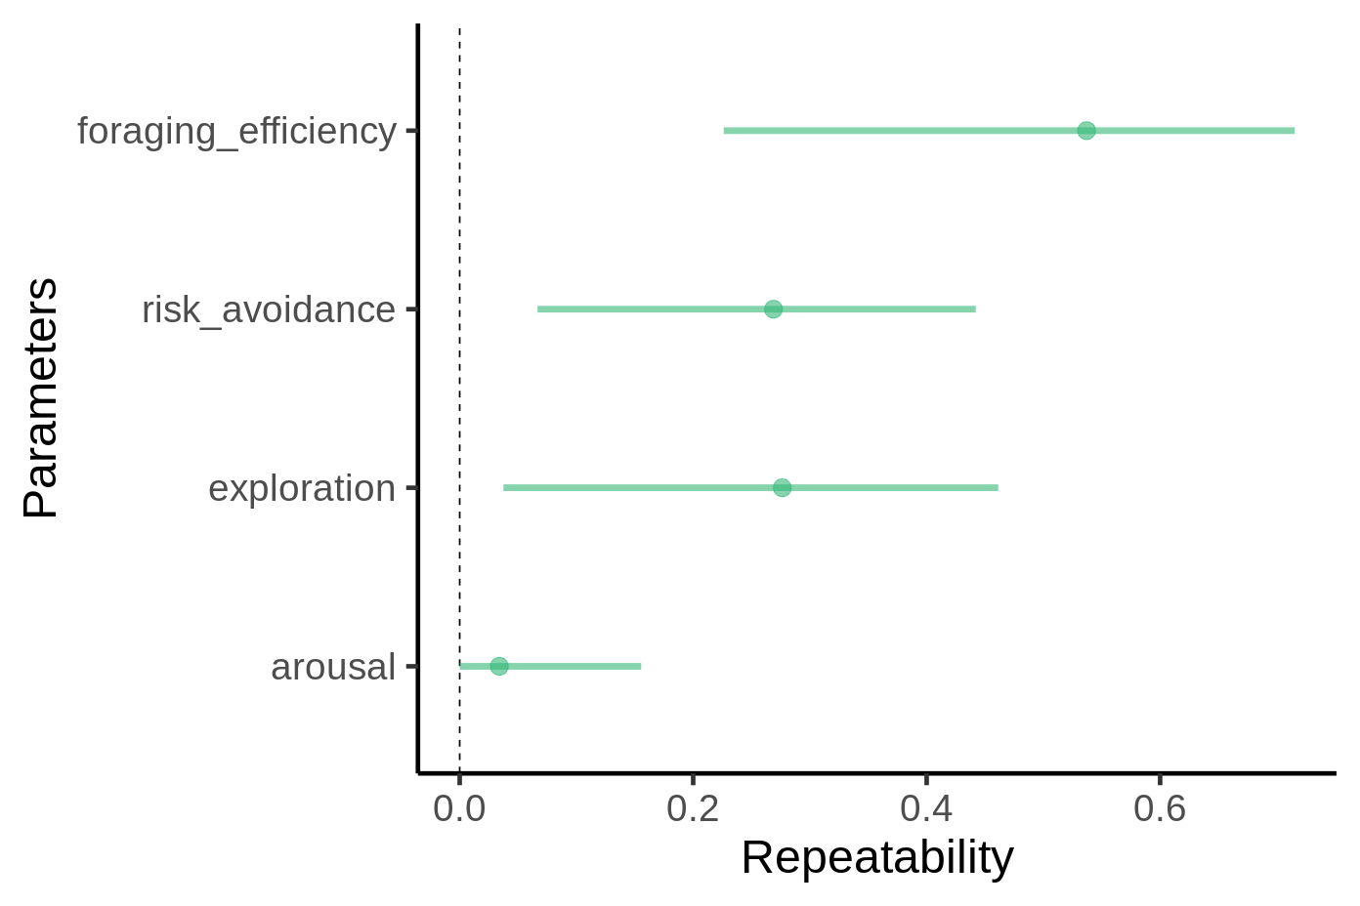

**Figure 3.** Foraging efficiency in the context of low and high levels of perceived risk of predation.

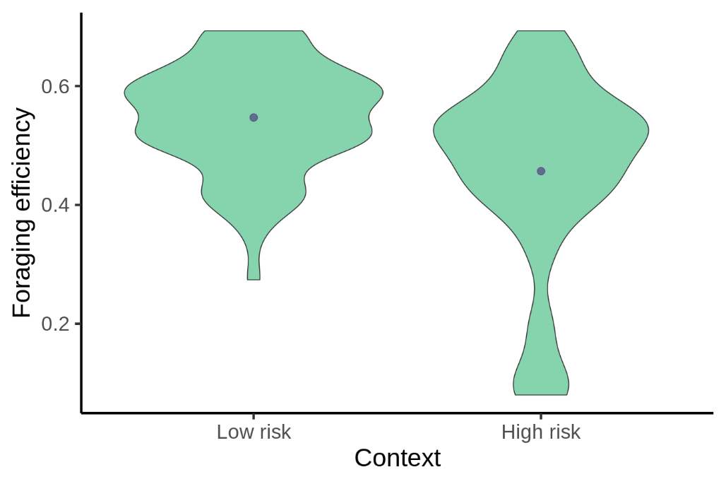

**Figure 3.** Foraging efficiency of long billed hermits in regard to their behavioural performance (exploration, risk avoidance and arousal) in the context of low and high levels of perceived risk of predation.

